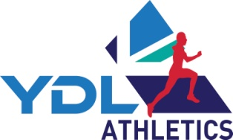
2026 YDL Match Hosting Support

Please make your claim as soon as possible after hosting a match.

If you host multiple matches please submit a claim for each match as soon as possible after each match.

No Claims will be accepted after 14th September 2026

Hosts will receive £750 fixed rate for up to 8 teams and £1000 for double headers & divisions up to 14 teams. Extra £200 paid for matches of 15 teams and above. Additional monies to be claimed if using precision measurement equipment. In order to process your Hosting Support Claim please complete and return the form below to: Nicola Thompson, YDL Finance Officer, 237 Coal Clough Lane, Burnley, Lancs, BB11 4DH

or Email completed forms: Nicola@ukydl.org.uk

Match details:
Host Team Name  (Composite name if applicable) |  |  |  |  | League | Upper  Lower
Region |  |  | Division |  | No. of Teams =
Match Date |  |  | Match Venue  (& postcode)

Precision measurement Support

(Flat rates of support can be claimed for hosts providing Photofinish and/or EDM)

Photo Finish Used | £300 | EDM Used | £80
Track Wind Gauge Used | £40 | Field Wind Gauge Used | £40

EDM Payment cannot be processed without the following details…
EDM Provider |  | EDM set up by (official)

Claimant’s details:

(Payments will only be made by BACS and only to hosting member teams)

Club Bank Account Name
Sort Code |  |  | Account Number

Contact Name
Phone number |  |  | Email | @

I certify that the above claim details are accurate and correct:
Signed |  | Printed name |  | Date

Please note that hosting claims for a match will only be paid after confirmation from the Administrator that acceptable results have been received.

